**­**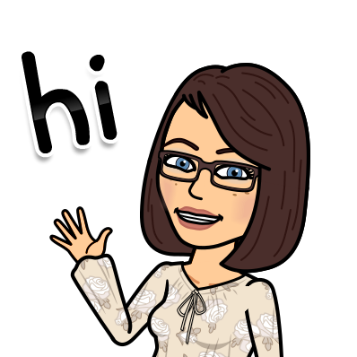

**Mrs. Picardi**

**Social Studies Class**

**Assumption Regional Catholic School**



Welcome to 6th Grade Ancient Civilizations! This year, you are going to learn about the history of the Ancient World. This syllabus will help you to familiarize yourself with my class and the expectations that I have for you. Welcome to the Junior High at Assumption Regional Catholic School!

**Organization**

Much of the daily work done in class such as notes and vocabulary will be organized in a single subject marble notebook. This notebook MUST be brought to class every day and will be collected for grading periodically. **The notebook should be used for Social Studies class only**. It will act as a study resource for you throughout the year. **Quizlet** will be available for review and instructions to access that will be sent home. Every class will begin with a **Question** **of the Day** which will be answered in your copybook. We will then say a daily prayer and begin our lesson. You will also use your **agenda book** daily to track weekly assignments and assessments. Textbooks are kept in the classroom but can be signed out when needed.

**Daily Materials**

- 1 single subject marble notebook

- pens and a highlighter

- plenty of loose-leaf paper

- Agenda book

-Portfolio

**Curriculum**

Each unit, we will complete a variety of assignments and assessments. This typically include writing summaries and answering critical thinking questions. Every quarter a current events article will be assigned. Requirements and due dates will be given out in class. A mid term in January and a final in June will be given. Study Guides will be handed out 2 weeks prior to the exams. **Videos and video clips will be used throughout the year. All are documentaries. Any questions on specifics please email me.**

**Units of Study**

Roman Empire

Byzantine and Muslim Civilizations

Civilizations of Africa

Early Civilizations of the Americas

Civilizations of Asia

Europe in the Middle Ages

Renaissance and Reformation

The Enlightenment

U.S Colonization

**Homework/Classwork**

Homework will be given on an as-needed basis in this class but you should be **studying your notes and vocabulary for our unit every night.** Homework is meant to support and solidify the learning you do in class each day. It also prepares you for assessments. Completing and turning in homework and classwork on time is an important part of being successful in class. You will always be made aware of due dates as these will be posted in **Renweb.**

**Classroom Expectations**

If these rules are not followed it will result in you losing points in your **classroom management grade** at the end of the quarter.

1. **Be Polite, Kind and Respectful**
2. **Be Prepared for Class**
3. **Follow Directions**
4. **Always Do Your Best-Participate**





**Grading**

I will use points for all assignments, projects and assessments. All work completed on loose leaf must be completed in blue or black ink with the heading on each paper. Students will always be made aware of assessments several days in advance.



**Make-Up Work**

It is your responsibility to find out what class-work and assignments you have missed while you were away. You will need to view my folder for 6th grade and get any make up work and get it completed in a timely manner.

**Late Work**

MC900000950[1]Turning assignments in late puts both the student and the teacher behind. You should make every effort to turn in work on time. Every day late will result in points deducted from your final grade.

**__________________________________**

**After reviewing this syllabus with your child please sign and detach this bottom half**

**Parent Printed Name_________________________**

**Parent Signature_____________________________**

**Parent Email________________________________**

**Student Signature____________________________**

**Digital Citizenship**

My curriculum is designed to help you become a productive digital learner who can navigate and utilize the Internet appropriately as needed to enrich your understanding of the topics we study.

Using technology to access digital media and tools at school is a privilege. Students are expected to be good digital citizens, which means demonstrating responsibility when it comes to: interacting with others, finding and processing information, citing and crediting your references, and maintaining a safe, positive digital presence.

**Reminders**

School and class reminders will be posted on my class web page. I will email reminders regarding assessments a few days before the assessment. **RenWeb** is updated frequently.

**Contact Information**

The quickest way to contact me directly throughout the year is through email.

**spicardi@arcsgalloway.org**

**Thank you!**

**Susan Picardi**

**Signed bottom half of syllabus is due by Wednesday, September 11th. This is a 10-point assignment 😊**